SIMATS ENGINEERING (SAVEETHA SCHOOL OF ENGINEERING)

Department of Computer Science and Engineering

ASSESSMENT TOOL 1 – APPLICATION BASED QUESTIONS

Course Code: | CSA06 | Course Title: | Design and Analysis of Algorithms
CO Assessed: | CO1 – Precision (BL1, BL2, BL3) | Assessment: | Assessment Tool 1 – Application Based Questions
Weightage: | 40% of CIA | Total Marks: | 100 (2 Questions × 50 Marks)
CO1 Statement: | Determine algorithm efficiency using asymptotic notations and mathematical techniques including Master Theorem and substitution method. (BL1, BL2, BL3)
Student Name: | Santhosh G | Reg. No.: | 192521035
Section / Batch: |  | Date:
Instructions to Students
- Answer BOTH questions. Each question carries 50 Marks. Total: 100 Marks.
- Clearly show all steps in derivations and complexity analysis.
- Use proper asymptotic notation (Big-O, Big-Θ, Big-Ω) wherever required.
- Justify each step in recurrence solving using appropriate methods.
- Neat presentation and logical explanation are mandatory

Question Type | Focus Area | Questions | Marks
Application-Based Questions | Apply Master Theorem and asymptotic analysis to real-world scenarios | Q1 – Q2 | Q1 50  Q2 –50
GRAND TOTAL: |  | 100 Marks

SECTION A – APPLICATION BASED QUESTIONS Q1

Application: Multi-Source Log Processing System
A distributed log processing platform divides input into two equal parts and performs logarithmic work during the merging phase due to search and synchronization operations. Apply the substitution method to solve the recurrence T(n)=2T(n/2)+log⁡n. Expand the recurrence in detail and derive the final complexity. Analyze performance for large log volumes. Interpret the result using asymptotic notation.

Q2

Application: Cloud Storage Processing System
A cloud system processes files using T(n) = 3T(n/2) + n. Apply the Master Theorem to find the time complexity. Identify parameters and justify the case selection. Analyze how this impacts performance for large storage systems. Interpret efficiency using asymptotic notation.

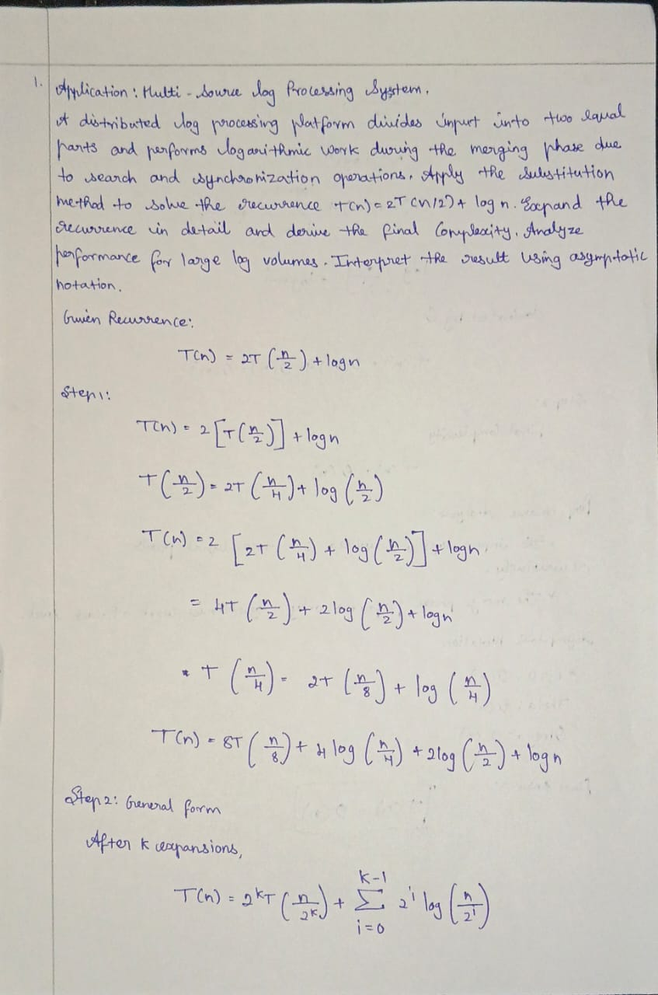

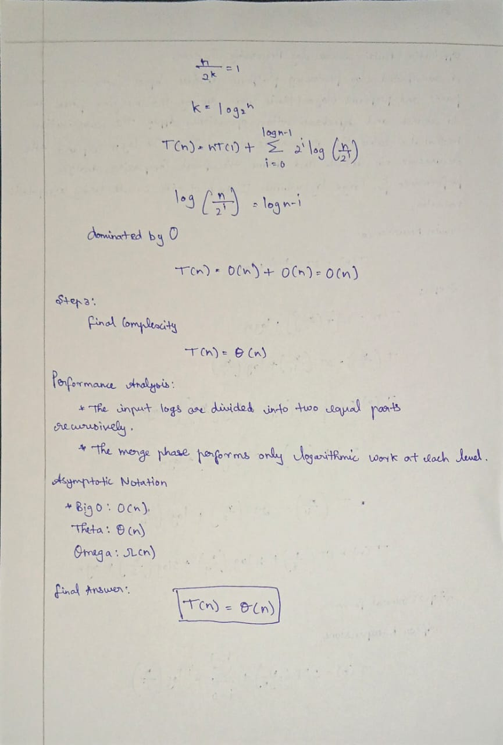

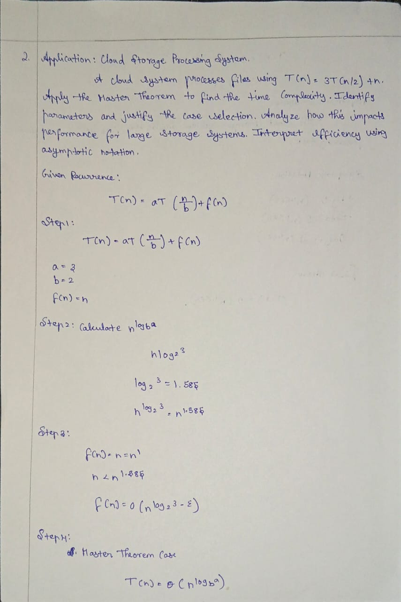

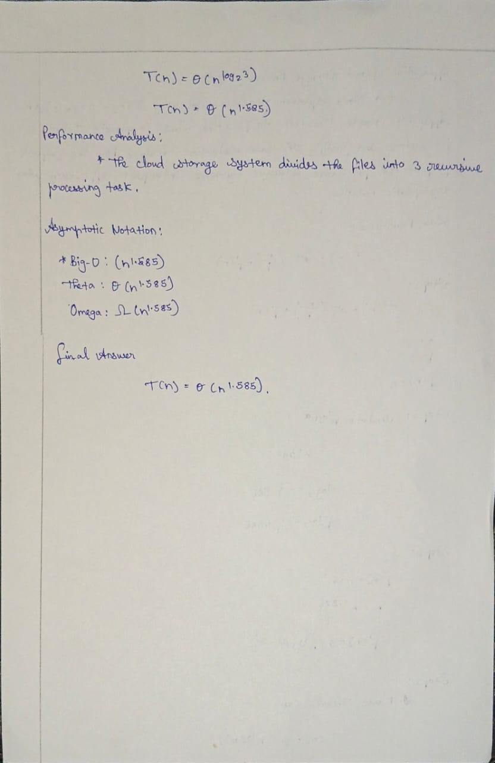

Code of Conduct
I (Name / Reg No) certify that this submission is my original work and that I have adhered to the guidelines specified for this assessment. I understand that any violation of academic integrity rules will result in disciplinary action.
Signature of the Student:

RUBRICS FOR CALCULATION

Criteria | Wt. | Level 4 – Exemplary | Level 3 – Proficient | Level 2 – Developing | Level 1 – Beginning
Understanding of Problem Context | 20% | Clearly understands the problem and accurately identifies all  requirements | Good understanding with minor gaps | Basic understanding; some requirements unclear | Poor  understanding or misinterpretation of the problem
Application of Concepts | 30% | Accurately applies appropriate concepts to solve complex problems | Applies relevant concepts correctly with minor errors | Applies basic  concepts with limited accuracy | Fails to apply appropriate concepts
Problem-Solving Approach | 20% | Logical, well-structured, and efficient approach | Mostly logical approach with minor gaps | Basic approach  with some  inconsistencies | Illogical or unclear approach
Accuracy of Solution | 20% | Completely correct solution with proper justification | Mostly correct with minor errors | Partially correct solution | Incorrect or incomplete solution
Clarity | 10% | Clear, well-organized, and properly explained solution | Understandable with minor clarity issues | Limited clarity and explanation | Poorly presented and difficult to understand

Marks Evaluation:
Question No. | Understanding of Problem Context (20%) | Application of Concepts (30%) | Problem-Solving Approach (20%) | Accuracy of Solution (20%) | Clarity (10%) | Total Marks
Q1
(50 Marks)
Q2
(50 Marks)
Overall Total (100)

Faculty In-charge | Course Coordinator | Head of Department
Signature: | Signature: | Signature:
Date: | Date: | Date:

